**COMPUTER GRAPHICS LAB**

Date: 07/08/2025 Batch: F3

Code 1:

#include <graphics.h>

#include <conio.h>

void main(){

    int gd = DETECT,gm;

    clrscr();

    initgraph (&gd, &gm,"C:\\TURBOC3\\BGI");

    setbkcolor(GREEN);

    printf("\t\t\t\n\nLINE");

    line(50,40,190,40);

    printf("\t\t\n\n\n\nRECTANGLE");

    rectangle(125,115,215,165);

    printf("\t\t\t\n\n\n\n\n\n\nARC");

    arc(120,200,180,0,30);

    printf("\t\n\n\n\nCIRCLE");

    circle(120,270,30);

    printf("\t\n\n\n\nECLIPSE");

    ellipse(120,350,0,360,30,20);

    getch();

    closegraph();

}

**Output:  
  
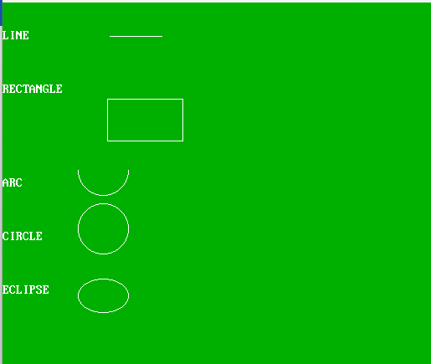**

**Code 2:**

#include <graphics.h>

#include <conio.h>

void main(){

    int gd = DETECT,gm;

    char str[] ="Hello World";

    clrscr();

    initgraph (&gd, &gm,"C:\\TURBOC3\\BGI");

    setbkcolor(GREEN);

    outtext("Hello World");

    outtextxy(100,100,"Hello World");

    outtextxy(200,100,str);

    getch();

    closegraph();

}

**Output:   
  
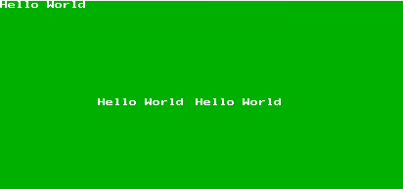**

**Code 3 (Pixel):**

#include <graphics.h>

#include <stdio.h>

#include <conio.h>

void main(){

    int gd = DETECT,gm,color;

    initgraph(&gd,&gm,"C:\\TURBOC3\\BGI");

    putpixel(85,35,GREEN);

    putpixel(30,40,RED);

    putpixel(115,50,YELLOW);

    putpixel(135,50,CYAN);

    putpixel(45,60,BLUE);

    putpixel(20,100,WHITE);

    putpixel(200,100,LIGHTBLUE);

    putpixel(150,100,LIGHTGREEN);

    putpixel(200,50,YELLOW);

    putpixel(120,70,RED);

    getch();

    closegraph();

}

**Ou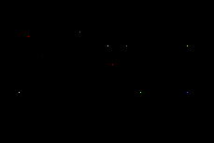tput:**